Results for p as a response variable, and 16 predictor variable(s).

n: 65535 r: 0.907 r²: 0.822 r²adj: 0.822 F: 18968.279 P: 0

Akaike's Information Criterion (AICc): -127152.712

Variable Coeff. Std Coeff. VIF Std Error t P Value

Constant 3.821 0 0 0.014 277.826 <.001

bio_15 -0.005 -0.202 6.619 <.001 -47.793 0

bio_19 -0.008 -0.497 4.887 <.001 -136.511 <.001

bio_3 -0.034 -0.553 3.341 <.001 -183.907 <.001

bio_4 <.001 -1.051 4.571 <.001 -298.533 0

CST -0.002 -0.014 1.116 <.001 -8.07 <.001

HII 0.013 0.329 1.878 <.001 145.656 <.001

LUCC -0.002 -0.12 1.209 <.001 -66.11 <.001

PC -33.06 -0.056 1.015 0.983 -33.648 <.001

s01 0.672 0.088 1.793 0.017 39.771 <.001

s02 0.23 0.029 1.485 0.016 14.53 <.001

s03 1.265 0.16 1.859 0.018 71.462 0

s04 -0.716 -0.101 1.336 0.013 -53.019 <.001

s05 0.127 0.016 1.261 0.014 8.841 <.001

s06 0.703 0.093 1.136 0.013 53.04 <.001

s07 0.088 0.012 1.098 0.013 6.745 <.001

s08 0.574 0.076 1.302 0.014 40.404 0

Condition Number: 5.976

Mean of Correlation Matrix: 0.131

1st Eigenvalue divided by m: 0.188

Descriptive Statistics:

p Estimated Residuals

Min 0.001 -0.404 -0.448

Max 0.782 0.916 0.553

Mean 0.252 0.252 <.001

Std.Dev. 0.218 0.197 0.092

Skewness 0.192 0.099 0.128

Kurtosis-495544223.611 -495545217.694 -495551603.263

Partial Regression Results:

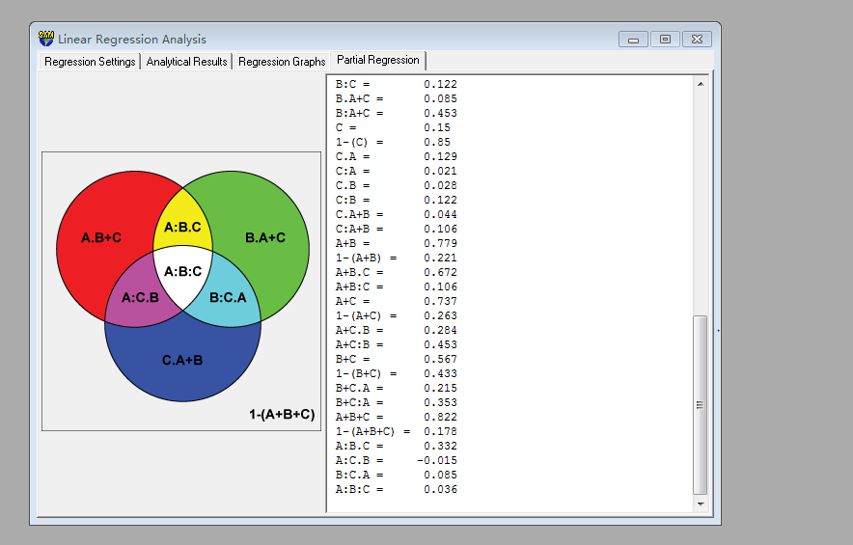

Predictor set {A}:

bio_15

bio_19

bio_3

bio_4

Predictor set {B}:

CST

HII

LUCC

PC

Predictor set {C}:

s01

s02

s03

s04

s05

s06

s07

s08

A = 0.608

1-(A) = 0.392

A.B = 0.24

A:B = 0.368

A.C = 0.587

A:C = 0.021

A.B+C = 0.255 a

A:B+C = 0.353

B = 0.539

1-(B) = 0.461

B.A = 0.171

B:A = 0.368

B.C = 0.417

B:C = 0.122

B.A+C = 0.085 b

B:A+C = 0.453

C = 0.15

1-(C) = 0.85

C.A = 0.129

C:A = 0.021

C.B = 0.028

C:B = 0.122

C.A+B = 0.044 c

C:A+B = 0.106

A+B = 0.779

1-(A+B) = 0.221

A+B.C = 0.672

A+B:C = 0.106

A+C = 0.737

1-(A+C) = 0.263

A+C.B = 0.284

A+C:B = 0.453

B+C = 0.567

1-(B+C) = 0.433

B+C.A = 0.215

B+C:A = 0.353

A+B+C = 0.822

1-(A+B+C) = 0.178

A:B.C = 0.332 d

A:C.B = -0.015 e

B:C.A = 0.085 f

A:B:C = 0.036 g